Draw a coffe day ordering system. A coffe coffee day shop vending machine dispenses coffee to customers. Customers order coffee by selecting a recipe from a set of recipes. Customers pay for the coffee using coins. Change is given back, if any, to the customers. The ‘service assistant’ loads ingredients (coffee powder, milk, sugar, water, chocolate) into the coffee machine. The ‘service assistant’ adds recipe by indicating the name of the coffee, the units of coffee powder, milk, sugar, water, chocolate to be added as well as the cost of the coffee. The service assistant can also edit and delete a recipe. Develop the use case diagram for the specification above**.**

**Aim**

To design a Coffee Day Ordering System using a Use Case Diagram that illustrates the interaction between customers, the coffee vending machine, and the service assistant.

## **Procedure**

### **Step 1: Identify the Actors**

* **Customer**: Orders coffee, inserts coins, receives coffee and change.
* **Service Assistant**: Manages recipes and loads ingredients.
* **Coffee Machine (System)**: Processes orders, dispenses coffee, and returns change.

### **Step 2: Identify the Use Cases**

* **Order Coffee** (Customer)
* **Insert Coins** (Customer)
* **Receive Coffee and Change** (Customer)
* **Load Ingredients** (Service Assistant)
* **Add Recipe** (Service Assistant)
* **Edit Recipe** (Service Assistant)
* **Delete Recipe** (Service Assistant)

### **Step 3: Define the Relationships**

* **Customer → Order Coffee → Insert Coins → Receive Coffee & Change**
* **Service Assistant → Load Ingredients**
* **Service Assistant → Add/Edit/Delete Recipe**

### **Step 4: Draw the Use Case Diagram**

* Represent **Actors** as stick figures.
* Represent **Use Cases** as ovals.
* Use **Associations** (lines) to connect actors to use cases.

### **Step 5: Add System Boundary**

* Enclose the **Coffee Vending Machine** use cases inside a rectangular box labeled **"Coffee Day Ordering System"**.

### **Step 6: Review and Validate**

* Ensure all functionalities are included.
* Check relationships between actors and use cases.

### **Step 7: Finalize and Present**

* Clearly label actors, use cases, and the system boundary.
* Present the **Use Case Diagram** as a visual representation of the system.

Use case diagram

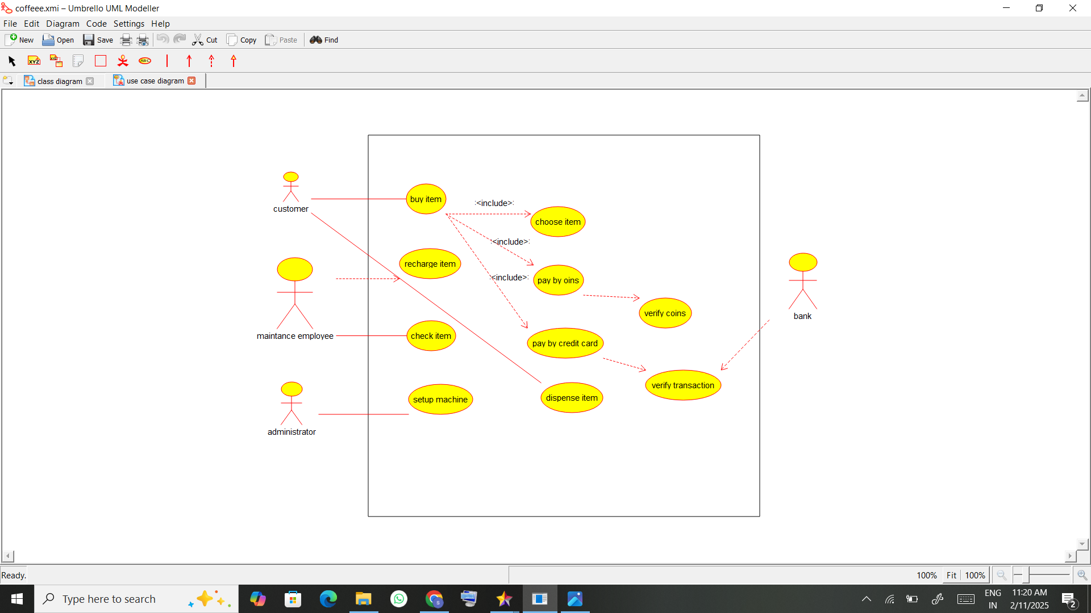

Result:

The **Coffee Day Ordering System** is designed to automate coffee vending operations, ensuring efficiency for customers and service assistants. The system enhances convenience by managing orders, payments, and inventory, making coffee vending more user-friendly.